File input – The user can select the following ‘File Types’ to make the connection to.
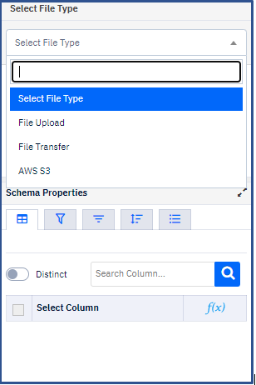
File Upload - User can select the existed file that needs to be uploaded on SCIKIQ from below option.
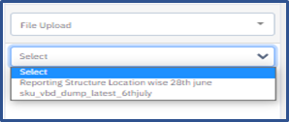
Different files that can be uploaded are as below:-
- FTP/SFTP
- Excel/CSV
- S3 etc
File Upload - User can create FTP/SFTP file connection from 'Manage Data Source' to transfer any file to SCKIQ database from client.
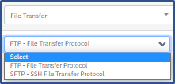
AWS S3 - User can create Amazon S3 file connection from 'Manage Data Source' to transfer any file to SCKIQ database from client.
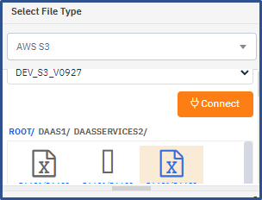
API - User can create http API connection from 'Manage Data Source' to make link through this option on SCIKIQ and connect to database of client. Once the connection is made, API can be selected in the below section of ETL and then the data frame can be saved accordingly.
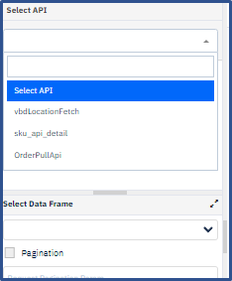
The user also gets 2 more options below:-
Pagination - Here the user gets an option to to divide a large data into smaller discrete pages. User can mention API call wait time/No of retries in the below section as well.
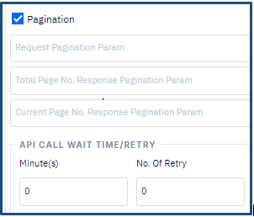
Save Data On Failure - User can also select option of saving data in case of ETL job failure.


